

BACHELOR THESIS
BACHELOR IN COMPUTER SCIENCE

Mentor: Student:
Prof. Ass. Dr. Rrezart Prebreza Alban Krasniqi
Prishtinë, 2026

BACHELOR THESIS
TITLE:
ASYMMETRIC SELF-PLAY IN THE BERLIN DEFENCE
(Vetë-luajtja asimetrike në Mbrojtjen e Berlinit)



Mentor: Student:
Prof. Ass. Dr. Rrezart Prebreza Alban Krasniqi

Prishtinë, 2026

AUTHOR'S DECLARATION
The undersigned, Alban Krasniqi, a student at UNI-Universum International College Powered by Arizona State University, Bachelor in Computer Science, author of this written work entitled “Vetë-luajtja asimetrike në Mbrojtjen e Berlinit / Asymmetric Self-Play in the Berlin Defence”, prepared under the supervision of mentor Prof. Ass. Dr. Rrezart Prebreza.
I DECLARE
- This bachelor thesis is based on the results of my theoretical and empirical research;
- The printed form of this written work is identical to the electronic form submitted by me;
- The text of this thesis has been edited linguistically and technically in accordance with the Technical Guidelines of UNI-Universum International College for written works, meaning that I cited the works and ideas of other authors in this bachelor thesis in accordance with those guidelines;
- I am aware that plagiarism (in written or graphic form) is a criminal offence and that I may be prosecuted;
- I am aware of the consequences that a proven case of plagiarism may have, in accordance with the relevant rules of UNI-Universum International College;
- I have obtained all necessary permissions to use the data and works of other authors that are (in written or graphic form) referenced in this bachelor thesis, and I have marked them clearly;
- I have acted in accordance with ethical principles during the preparation of this thesis;
- I grant UNI-Universum International College, free of charge, non-exclusively, geographically and without time limit, the right to store this document in electronic and physical form, the right to reproduce this document, and the right to make this document available to the public in the Republic of Kosovo and beyond;
- I consent to the publication of my personal data included in this document and in this declaration when this bachelor thesis is published in electronic and physical form.

Prishtinë, __/__/____ Author's signature: ____________________________
(Date of the diploma defence)
ACKNOWLEDGEMENTS
On completing this bachelor thesis I express my gratitude to everyone who stood by me during my studies. I thank my family for their unconditional support during the programme at UNI-Universum International College Powered by Arizona State University.
I thank the mentor of this thesis, Prof. Ass. Dr. Rrezart Prebreza, for academic supervision. Any remaining error is the student’s responsibility.
I thank the open communities of Leela Chess Zero and Stockfish, and the authors of PyTorch and python-chess. The thesis rests on Silver et al. (2017b), Tomašev et al. (2022), Tesauro (1995), Howell (2018) and Lawson (2018). There is no conflict of interest and no external funding.

ABSTRAKTI
Ky studim ka për qëllim të projektojë, të implementojë dhe të vlerësojë një protokoll vetëluajtjeje me objektiva asimetrike, të kufizuar te Mbrojtja e Berlinit (ECO C65). Problemi është simetria e funksionit të qëllimit në vetëluajtjen klasike: të dyja palët maksimizojnë të njëjtën pritje {fitore, remis, humbje} (Silver et al., 2017b), ndërsa në lojën njerëzore një palë mund të kërkojë fitoren dhe tjetra të kënaqet me remis. Pyetja kërkimore është nëse ndryshimi i Q-së së kërkimit gjatë vetëluajtjes rrit pikën e të ziut specialist kundër një të bardhe standarde. Objektivat janë: (i) ndërtimi i tre motorëve UCI (lc0-standard me Q = W − L; lc0-variant me dy specialistë dhe DrawScore; lc0-aggressive, i vlerësuar me Q = W si i bardhë); (ii) ngrirja e një buxheti të barabartë trajnimi; (iii) testimi i hipotezave me ngjyra fikse. Metoda është sasiore-eksperimentale: rrjet 6×64 SE-ResNet, 120 nyje MCTS, ndalesë games003440.pt, N = 100 parti për ndeshje. Gjetja kryesore: i ziu asimetrik shënoi 29/100 kundrejt 52/100 të kontrollit (Δs = −0.23, interval i besimit 95% [-0.332, -0.128], z ≈ -4.44). Si i bardhë kundër së njëjtës të zezë standarde: standardi 48/100, varianti 35.5/100, lc0-aggressive 26/100. Ablacioni 2×2 mbi të njëjtin instant dha 53, 44 dhe 45 pikë për qelizat A–C. H2 u mbështet (70% parti vendimtare kundrejt 54%, p ≈ 0.020), por pa pikë shtesë. Hipoteza alternative H1 u hodh poshtë në drejtimin e kundërt. Përfundimi: në këtë protokoll, struktura klasike e shpërblimit performoi më mirë se asimetria e paketuar; kontributi është evidencë negative e kontrolluar për ndërhyrjen e Q-së gjatë vetëluajtjes në shkallë të cekët, jo një rekord Elo. Nuk ka subjekte njerëzore. Shpërndarja reale WDL ruhet në kokën e vlerësimit.
Fjalë kyçe: vetë-luajtje (self-play), mësim përforcues, objektiva asimetrike, DrawScore, Q = W, Mbrojtja e Berlinit, lc0-standard, lc0-variant, lc0-aggressive, MCTS / PUCT.

ABSTRACT
This study designs, implements and evaluates an asymmetric self-play protocol restricted to the Berlin Defence (ECO C65). The problem is the symmetry of the objective in classical self-play: both colours maximise the same {win, draw, loss} return (Silver et al., 2017b), whereas human play often splits those aims. The research question is whether changing search Q during self-play raises specialist Black’s score against a standard White. The objectives are to build three comparable UCI engines (lc0-standard with Q = W − L; lc0-variant, a dual-agent pair with Lc0 DrawScore; lc0-aggressive, evaluated as White with Q = W), freeze an equal training budget, and test the hypotheses in fixed-colour matches. The method is quantitative-experimental: a 6×64 SE-ResNet, 120 MCTS visits, checkpoint games003440.pt, N = 100 games per match. Main result: asymmetric Black scored 29/100 versus 52/100 for standard Black (Δs = −0.23, 95% CI [-0.332, -0.128], z ≈ -4.44). As White against the same standard Black: standard 48/100, variant 35.5/100, aggressive 26/100. A search-only 2×2 ablation on the same freeze scored 53, 44 and 45 for cells A–C. H2 was supported (70% decisive games versus 54%, p ≈ 0.020) without extra points. Alternative hypothesis H1 is rejected in the opposite direction. The conclusion is that, in this protocol, the classical reward structure outperformed packaged asymmetry; the contribution is controlled negative evidence on search-Q intervention during self-play at a shallow scale, not an Elo record. There are no human participants. True chess WDL is kept in the value head. All games begin 1.e4 e5 2.Nf3 Nc6 3.Bb5 Nf6.
Keywords: self-play, reinforcement learning, asymmetric objectives, DrawScore, win-only Q, Berlin Defence, lc0-standard, lc0-variant, lc0-aggressive.

Technical summary
Table 1 summarises the frozen parameters, variables and hypotheses. The empirical decision is given in Chapter 5.
Table 1. Technical summary
Item | Frozen value
Engines | lc0-standard, lc0-variant, lc0-aggressive
Architecture | 6×64 SE-ResNet, 112 planes, policy 1858, WDL
Opening / s_0 | Berlin C65, after 3…Nf6
MCTS visits | 120 / move, training and tournament
Evaluation freeze | games003440.pt, equal budget
N / match | 100 games, fixed colours
Hardware | NVIDIA RTX 4060 8 GB
Language / libraries | Python, PyTorch, python-chess
H0 | Packaged asymmetry does not raise Black’s score (s_var ≤ s_std)
H1 (alternative) | s_var > s_std as Black, against the same standard White
Independent variable (H1) | search package: dual-net + DrawScore + parent-relative FPU, versus Q = W − L
Dependent variable (H1) | Black’s s (FIDE points: 1 / ½ / 0)
Control variables | FEN C65, 120 visits, freeze 3440, White = lc0-standard, contempt off
H2 (secondary) | more decisive games for the variant as Black
H3 (not H1) | lc0-aggressive as White with Q = W (WhiteQ=winonly)

Table of contents
ABSTRAKTI v
ABSTRACT vi
Technical summary vii
Table of contents viii
List of tables x
List of figures xi
List of abbreviations xi
Chapter 1: Introduction 1
1.1 Background of the study 1
1.2 Research problem 2
1.3 Purpose of the study 2
1.4 Significance of the study 3
1.5 Definition of terms 3
1.6 Theoretical framework 3
1.7 Research questions and hypotheses 3
1.8 Limitations, delimitations and assumptions 4
1.9 Organisation of the study 4
1.10 Chapter summary 5
Chapter 2: Literature review 6
2.1 Theoretical bases of self-play and evaluation 6
2.2 Prior work on engines, contempt and the Berlin 7
2.3 Review conclusion and gaps 9
Chapter 3: Research methodology 10
3.1 Introduction 10
3.2 Research approach 10
3.3 Sample 11
3.4 Data collection 11
3.5 Instruments and technical specifications 11
3.6 Data-analysis techniques 15
3.7 Ethical aspects 15
3.8 Methodological limitations 16
3.9 Chapter summary 16
Chapter 4: Data analysis 17
4.1 Primary data 17
4.2 Metrics and confidence intervals 17
4.2.1 Assumptions of the statistical tests 18
4.3 Chapter summary 18
Chapter 5: Results 19
5.1 H1: Black’s score 19
5.2 H2: decisive games 21
5.3 H3: lc0-aggressive as White 21
5.4 The 2×2 ablation 22
5.5 Descriptive statistics 23
5.6 Summary of findings 25
Chapter 6: Discussion and conclusions 26
6.1 Introduction to the discussion 26
6.2 Interpretation of the results 26
6.3 Relation to the literature 27
6.4 Implications 27
6.5 Recommendations for future research 27
6.6 Conclusion 28
Chapter 7: Limitations 29
7.1 Computational resources 29
7.2 Sample size and opening 29
7.3 Identification and validity 29
References 30
Annexes 33
Annex 1. Berlin position and continuations 33
Annex 2. Reward scheme 33

List of tables
Table 1. Technical summary vii
Table 2. Literature synthesis: premises, sources and gaps. 9
Table 3. Comparison of the objective functions used in this thesis. 12
Table 4. ECO coding of the Berlin Defence and the thesis position FEN. 13
Table 5. Executed hyperparameters (values frozen before the tournament). 14
Table 6. The 2×2 ablation. H1 remains the last row versus the first; A–C isolate Q and the network. 15
Table 7. Tournament metrics and their definition. 18
Table 8. Decision rule for H1 — applied without change. 18
Table 9. Main tournament. W/D/L are from the viewpoint of the first-named side. The Elo column is a 400 log10(s/(1−s)) note, unstable at the edges (s ≈ 0.26–0.29); the decision follows Δs and Table 8, not Elo. 19
Table 10. Search visits were kept 120/120; 64 and 256 were not varied. 21
Table 11. Draws, decisions, mean length and Wall entry (q_ex). Exact C67: 0/100 in all four matches. 21
Table 12. Search ablation, N = 100, White fixed as lc0-standard. 22
Table 13. Termination mode (Termination header). The first three columns: H1 plus the auxiliary (300 games); the fourth: H3. Three “adjudication” games in H3 (max_game_ply = 512). 23
Table 14. Frequency of White’s fourth move (SAN), N = 100 per column. 24
Table 15. Numerical scheme used (not an alternative after the tournament). 33

List of figures
Figure 1. Self-play cycle: Berlin FEN, MCTS, weight update, tournament checkpoint. 10
Figure 2. Evaluation matches, with fixed colours and 120 visits / move. 12
Figure 3. Classic Q (W−L), DrawScore (1−2L / 2W−1) and Q = W on the same WDL. 13
Figure 4. The three engines: lc0-standard, lc0-variant, lc0-aggressive. 14
Figure 5. Black’s score against the same White lc0-standard. 20
Figure 6. Black’s WDL: 14–30–56 (variant) versus 29–46–25 (standard). 20
Figure 7. White’s score against the same Black lc0-standard. 22
Figure 8. Black’s score in the ablation cells, N = 100. 23
Figure 9. Termination by Termination header, four matches. 24
Figure 10. Fourth move: lc0-standard as White (Nd4/h4/c4) and lc0-aggressive (Nh4/g3/Ke2). 25

List of abbreviations
APA - American Psychological Association - Shoqata Psikologjike Amerikane
CE - Cross-entropy - Entropi e kryqëzuar
CI - Confidence interval - Interval i besimit
ECO - Encyclopaedia of Chess Openings - Enciklopedia e hapjeve të shahut
FEN - Forsyth–Edwards Notation - Shënimi Forsyth–Edwards
FIDE - Fédération Internationale des Échecs - Federata Ndërkombëtare e Shahut
FPU - First Play Urgency - Urgjenca e lojës së parë
Lc0 - Leela Chess Zero - Leela Chess Zero
MCTS - Monte Carlo Tree Search - Kërkim me pemë Monte Carlo
NNUE - Efficiently Updatable Neural Network - Rrjet nervor i përditësueshëm në mënyrë efikase
PGN - Portable Game Notation - Shënimi i bartshëm i partive
PUCT - Predictor + Upper Confidence bound applied to Trees - Parashikuesi me kufi të sipërm besimi në pemë
RL - Reinforcement learning - Mësim përforcues
SE - Standard error - Gabim standard
SE-ResNet - Squeeze-and-Excitation residual network - Rrjet i mbetur me shtrydhje dhe ngacmim
SPRT - Sequential probability ratio test - Test sekuencial i raportit të gjasave
TD - Temporal difference - Diferencë kohore
UCI - Universal Chess Interface - Ndërfaqja universale e shahut
VRAM - Video random-access memory - Memorie video me qasje të rastësishme
WDL - Win, draw, loss - Fitore, remis, humbje

Chapter 1: Introduction
This chapter situates the study: background, problem, purpose, significance, terms, theoretical framework, questions and hypotheses, limitations, delimitations, assumptions, and the organisation of the remainder.

1.1 Background of the study
This thesis addresses a narrow question about chess engines. Modern engines are trained by self-play: two sides play against each other and, in the classical scheme, share the same objective. Silver et al. (2017b) raised this principle to chess with AlphaZero: the network (p, v) = f_θ(s) learns a policy and a value v ≈ E[z | s], where z ∈ {−1, 0, +1} at a terminal position. The scheme is symmetric: White and Black maximise the same return.
In human play the aim is not always symmetric. One side may be content with a draw; the other seeks a win. Howell (2018) and Lawson (2018), in the consultative game of April 2018 against AlphaZero, chose the Berlin Defence; Lawson noted that the engine did not change its style against a weaker opponent. Leela Chess Zero, from v0.30.0, offers contempt / WDL rescale in search, over a classically trained network (Leela Chess Zero, 2023). This thesis asks a different question: what happens if the objective function is changed during self-play, not only as a UCI option after the fact?
Network self-play has moved from TD-Gammon (Tesauro, 1995) to AlphaZero (Silver et al., 2017b) and to Lc0 with WDL. The problem here is not to build the world’s strongest engine. The problem is the hidden choice in z ∈ {−1, 0, +1}: a draw is neutral for both colours. That is reasonable if the aim is Elo against other engines. It is not reasonable if the aim is to learn a style: a Black that seeks a win in a draw-prone opening, against a White that is content with a draw.
The Berlin Defence (1.e4 e5 2.Nf3 Nc6 3.Bb5 Nf6) became a theoretical weapon when Kramnik used it against Kasparov in London 2000. Tomašev et al. (2022) recall that episode: engines of that time valued the Berlin endgame around +1 for White; modern engines see it as equal. The Wall structure (C67) remains a reference; this thesis’s s_0 is C65, so that the policy itself chooses whether to enter the Wall. Restricting play to the Berlin FEN also has an engineering reason. Self-play from startpos, with this thesis’s resources, would spend the sample on other openings. Lc0 has discussed training not only from startpos (Leela Chess Zero, 2019). This thesis takes that idea in the strong form: every training and evaluation game starts from the same C65 FEN.

1.2 Research problem
The problem is twofold. First, classical self-play does not offer a side that treats the draw differently from the opponent during learning: both sides share z. Second, Lc0 contempt changes Q only in use, over an already mature θ; it does not show what happens if DrawScore and two specialists co-evolve from the same draw-prone FEN, with equal resources. Without a frozen protocol, it is unknown whether search asymmetry raises Black’s FIDE score or harms it.
The asymmetry implemented in lc0-variant is intentional. The value head learns true chess WDL. Search converts that into Q with the product in classic Lc0, Q = (W − L) + d_s D, where d_s = +1 for White (Q = 1 − 2L) and d_s = −1 for Black (Q = 2W − 1). That product is the line wl + draw_score × d; Search::GetDrawScore flips the sign of draw_score by the side to move (Leela Chess Zero, n.d.-b). It is not v0.30.0 WDL-rescale contempt (Naphthalin, 2023; Leela Chess Zero, 2023). In addition, the variant has two specialists that co-evolve. lc0-standard remains the control: one network, Q = W − L. lc0-aggressive is a single network with classic FPU; its default.yaml remains q_mode = asymmetric (White W − L, Black Q = W). The retained diploma match plays this net as White with WhiteQ = winonly, so Q = W in search. Evaluation is not “how beautifully it plays”, but tournament points with equal resources.

1.3 Purpose of the study
The purpose is to design, implement and evaluate an asymmetric self-play protocol restricted to the Berlin Defence. The learning object in the variant is Black (and the White specialist that seeks a draw in search). Success of H1 is measured by tournament points of variant Black against standard White, compared with standard Black against the same White. The aim is not to defeat AlphaZero. The aim is to make testable — and now tested — the hypothesis that changing the objective function during self-play improves Black’s result.
The specific objectives are: (O1) To formalise the distinction among classic Q = W−L, Lc0 DrawScore, and Q = W, while keeping true WDL in the value head. (O2) To fix s_0 as FEN C65. (O3) To build lc0-standard. (O4) To build lc0-variant. (O5) To build lc0-aggressive. (O6) To run the tournament with fixed colours, N = 100, 120 visits, freeze 3440. (O7) To apply the metrics and the decision rule for H1. (O8) To archive the PGNs as proof that every game starts with the Berlin.

1.4 Significance of the study
Practical significance: for engines with limited resources, the study shows whether retraining with frozen DrawScore is worth it compared with contempt over a classical θ. Theoretical significance: changing Q during self-play is testable; a hypothesis that is reasonable from the literature (Silver et al., 2017b; Sutton & Barto, 2018; Leela Chess Zero, 2023) can fail at a shallow scale. Methodological significance: the decision rule was frozen before the scores. The claimed contribution is limited: three UCI engines, an executed protocol, and a controlled finding — not an Elo record. The UNI guide requires the finding in the abstract. Lunenburg and Irby (2008) leave interpretation and test figures for the results chapter; this section therefore does not repeat them.

1.5 Definition of terms
Terms are used with these operational meanings. Standard engine: this thesis’s lc0-standard (checkpoint games003440.pt), not world Stockfish. Variant: lc0-variant with the same checkpoint, two specialists, DrawScore, parent-relative FPU. Aggressive: lc0-aggressive, the same checkpoint; the retained match is the one in which it plays White against lc0-standard as Black, with WhiteQ = winonly. Success of H1: Table 8, applied to Table 9. Berlin: the C65 FEN of Annex 1. Q: the PUCT scalar computed from WDL. DrawScore: Q = (W − L) + d_s D, d_s = ±1. Q = W: draw and loss have Q = 0. s: mean FIDE score (1 / ½ / 0). Δs: s_var − s_std as Black. Freeze 3440: the equal comparison budget, not the script’s 10 000 ceiling.

1.6 Theoretical framework
The framework is reinforcement learning with self-play and PUCT search (Sutton & Barto, 2018; Silver et al., 2017b; Kocsis & Szepesvári, 2006). Value exists only relative to the reward; changing Q is a change of the search task, not of the FIDE label, because the WDL head remains CE over true (W, D, L). The operational model: three lines with the same 6×64 body, the same FEN, the same 120 visits; only the search package changes and, in the variant, the number of specialists. Elo (1978) serves as a note, not as the decision. The decision follows Δs and the 95% interval.

1.7 Research questions and hypotheses
The main question (P1) is quantitative and comparative: does asymmetric Black obtain more FIDE points than standard Black, against the same standard White, in Berlin C65 with 120 visits and freeze 3440? The independent variable is the search package (control: one net, Q = W − L, classic FPU; H1 treatment: dual-net, DrawScore, parent-relative FPU). The dependent variable is Black’s s. Auxiliary questions: (P2) does the rate of decisive games rise for the variant as Black? (P3) does Q = W raise White’s score against the same Black? (P4) does DrawScore alone, without retraining, explain the harm of H1?
H0 (null, frozen before the tournament): s_var ≤ s_std, where both sides are Black against the same White lc0-standard. H1 (alternative): s_var > s_std. Rule: (i) lower 95% bound of Δs > 0 → H1 supported; (ii) upper bound < 0 → H1 rejected in the direction of harm; (iii) otherwise undecided. This section freezes the rule. The decision, with values, is given in Chapter 5.
H2, secondary: the decisive-game rate of the variant as Black is higher than that of the standard–standard control. H0 of H2: 1−d_var = 1−d_std. H2 has no frozen decision rule like Table 8; the test is given in Chapter 5.
H3, labelled, not H1: lc0-aggressive is not DrawScore asymmetry. The retained evaluation match plays it as White with Q = W (WhiteQ = winonly) against standard as Black, the same Black as in the variant–standard match. It is not claimed that a good result here would reopen H1.

1.8 Limitations, delimitations and assumptions
Limitations (weaknesses of the study, not choices): one RTX 4060 8 GB card; N = 100; the H1 treatment changes more than one scalar; the ablation did not retrain θ; games after eight half-moves with temperature are only partly independent. These are developed in §§3.8 and 7.
Delimitations (choices that close the field): Berlin C65 only; 6×64 body; 120 visits; freeze 3440; three Python UCI engines, not the C++ lc0 binary; UCI contempt = off; no transfer test against Stockfish; the pilot match with lc0-winonly as Black is outside hypotheses H1–H3. Generalisation to other openings remains future work.
Assumptions: python-chess reports FIDE terminals correctly; 120 visits are sufficient to compare two lines at the same scale, not to play C67 theory; the WhiteQ/BlackQ headers describe match search; aggressive default.yaml does not override the tournament’s WhiteQ = winonly.

1.9 Organisation of the study
Chapter 2 reviews the literature (introduction, development, conclusion and gaps). Chapter 3 gives the methodology (approach, sample, collection, instruments, analysis, ethics, methodological limitations). Chapter 4 specifies the corpus and the metrics. Chapter 5 presents the results without interpretation. Chapter 6 discusses, relates to the literature and gives the conclusion. Chapter 7 states the limitations. References follow APA 7. The annexes collect the FENs and the search_q listing. The unit tests, the PGNs and the weights are in the thesis folder, as noted in §3.7.
Chapter numbering follows the faculty form (seven chapters plus annexes). Lunenburg and Irby (2008, preface) allow adaptation of the five-chapter model to institutional requirements. Mapping: their introduction = Chapter 1; literature = Chapter 2; methodology = Chapters 3–4; results = Chapter 5; discussion and conclusions = Chapter 6, with separate limitations in Chapter 7 as required by the UNI guide (UNI-Universum International College, n.d.).

1.10 Chapter summary
The study tests whether the packaged asymmetric search package raises Black’s score in Berlin C65. H0: s_var ≤ s_std; H1: s_var > s_std. The IV is the search package; the DV is s. The chapters that follow give the literature, method, metrics, results, discussion and limitations.

Chapter 2: Literature review
This chapter reviews the literature that frames the research question: does changing the objective function during self-play raise Black’s score in the Berlin Defence? The review is not an encyclopaedia of computer chess. It builds three premises: (i) an engine’s style is a function of reward and search, not a separate aesthetic (Shannon, 1950; Silver et al., 2017b); (ii) Lc0 contempt changes search on an already trained network (Leela Chess Zero, 2023), whereas this thesis intervenes during self-play; (iii) the Berlin is a domain where draws are dense and the human analogy is documented (Kramnik & Kasparov, 2000; Tomašev et al., 2022; Lawson, 2018). The empirical papers that open the gap are from 2016–2023. Older sources are cited as theoretical bases, not as new evidence. The development has two themes (the basis of evaluation; engines, contempt and the Berlin). The chapter conclusion states the gaps that Chapter 3 turns into a protocol and Chapter 5 measures.

2.1 Theoretical bases of self-play and evaluation
Shannon (1950) divided chess programs into Type A (full expansion) and Type B (heuristic selection) and proposed a linear evaluation function. Newell et al. (1958) added the “good enough” view. Knuth and Moore (1975) analysed alpha-beta, the skeleton of engines such as Stockfish until leaves were replaced by a network. Campbell et al. (2002) closed the hand-crafted evaluation paradigm: style was the style of the function’s authors, not of a learned π*. For this topic the lesson is direct: if we want a side that treats the draw differently, we either code it (contempt) or learn it (a change of Q / of the side). The first line is rich; the second, in chess, is rare.
Tesauro (1995) showed with TD-Gammon that temporal-difference self-play can reach master level. Sutton and Barto (2018) place this in an MDP: V^π exists only relative to r. Changing r is not “style tuning”; it is a change of task. Mnih et al. (2015) brought deep Q-learning to Atari; Schulman et al. (2017) gave PPO. Heinrich and Silver (2016) studied self-play in imperfect information; Lanctot et al. (2019) gave OpenSpiel. Lai (2015), in Giraffe, showed that a TD network with limited search reaches club level without TPUs. This thesis takes Giraffe’s scale (a shallow net, few visits) and Sutton and Barto’s question (what is r?), restricted to one FEN.
Silver et al. (2016) combined human games, self-play and MCTS in AlphaGo. Silver et al. (2017a) removed human knowledge in AlphaGo Zero. Silver et al. (2017b) generalised the algorithm as AlphaZero. Citing z is required, because this thesis intervenes exactly there: a terminal position is scored −1 for a loss, 0 for a draw and +1 for a win (Silver et al., 2017b). The network minimises (z − v)² and matches p to MCTS π. Both colours share the same z. The “aggressive” style described by Sadler and Regan (2019) comes from E[z] against itself, not from a different objective. Schrittwieser et al. (2020) with MuZero also removed knowledge of the rules; that is outside this study’s scale. FIDE and a change of Q suffice.
FIDE (2023) defines termination: checkmate, stalemate, insufficient material, threefold repetition, fifty moves, and draw by agreement. In this thesis a game ends when python-chess reports a FIDE ending. There is no draw agreement between engines. Three layers must not be confused: the FIDE result (1 / ½ / 0) used by the match; the WDL label learned by the value head; the PUCT Q that chooses the move. Under FIDE points, chess remains zero-sum. Under DrawScore, White’s Q on a draw is +1 and Black’s is −1, so tree backup remains zero-sum in search utility but does not match the FIDE layer.
For N games with mean score s ∈ (0, 1), ΔR ≈ 400 log10(s/(1−s)) (Elo, 1978). For Berlin as Black, the expected s of two equal engines is not 0.5, because White moves first. Therefore H1 does not compare s with 0.5, but s_var with s_std, both as Black against the same White. Action selection follows PUCT (Kocsis & Szepesvári, 2006; Browne et al., 2012). These are the bases on which Chapter 3’s three engines are built.

2.2 Prior work on engines, contempt and the Berlin
Lc0 is the open attempt to reproduce AlphaZero, with WDL instead of a scalar, a moves-left head, and PUCT (Leela Chess Zero, n.d.-a). Two features connect directly to this thesis’s code. First: WDL rescale / contempt in v0.30.0 (Leela Chess Zero, 2023; Sadler, 2024). Contempt transforms WDL at search time; θ remains learned under a classical objective. The product used here, Q = (W − L) + d_s D, is the classic-search line wl + draw_score × d, and Search::GetDrawScore flips the sign by the side to move (Leela Chess Zero, n.d.-b). In lc0-variant that d_s is frozen during self-play. It is not the same as v0.30.0 WDL-rescale contempt, which changes the WDL distribution before Q is computed (Naphthalin, 2023; Leela Chess Zero, 2023). Second: train-not-only-from-startpos (Leela Chess Zero, 2019). This thesis takes the extreme version: one FEN, C65, for every line, so the difference is not “a different opening”.
This split matters for the claim. If someone turns on contempt over a public Lc0 net, they have not tested this thesis’s H1. H1 compares two θ trained here, with the same 6×64 body, from the same FEN, with UCI contempt = off in the match. The engine follows the 112-plane encoder, SE-ResNet, 1858 policy, WDL and PUCT with the documented constants — not the C++ lc0 binary, not t60/t80 nets.
Nasu (2018) described NNUE; Stockfish adopted it as a hybrid α–β + network (Stockfish developers, n.d.). Classical alpha-beta contempt shifts draw evaluation in use, analogously to WDL rescale. Fishtest uses SPRT to accept changes. The rule in Table 8 is a simplified analogue: freeze in advance, do not change N after seeing scores. H1 is not “does it beat Stockfish”. A transfer test against Stockfish, labelled as such, remains future work.
ECO codes the Berlin as C65 (3…Nf6), C66 (lines with d3) and C67 (the Wall, 4.O-O Nxe4 … 8.Qxd8+ Kxd8). This thesis’s FEN is C65 (Edwards, 1994). Choosing C65 leaves the Wall as a policy decision, not as s_0. Kramnik used the Berlin as a drawing weapon against Kasparov (Kramnik & Kasparov, 2000). Tomašev et al. (2022) note that engines of 2000 valued the Berlin endgame around +1 for White, modern engines as equal. McGrath et al. (2022) show that AlphaZero relearns opening concepts during self-play; that justifies restriction to a structure even a tabula rasa agent recognises. Cox (2008) describes the Wall for players.
Howell (2018) and Lawson (2018) made the limit of E[z] visible at the board: the human team allowed the Berlin; AlphaZero offered a draw; Lawson noted that the engine does not “play cute” against a weaker opponent. Lc0’s later contempt is a search-time response. This thesis asks whether an intervention during learning, realised as DrawScore plus two specialists, changes Black’s score in the Berlin.
In RL, r defines the task (Sutton & Barto, 2018). MORL studies reward vectors; this thesis does not solve a Pareto front at decision time. Each side has a scalar Q. In the standard, Q = W − L. In the variant, Q = (W − L) + d_s D with d_s = ±1, the classic-code product wl + draw_score × d (Leela Chess Zero, n.d.-b), not the WDL-rescale of pull request #1791 (Naphthalin, 2023). In lc0-aggressive, default.yaml remains q_mode = asymmetric; the retained evaluation match sets White to Q = W (WhiteQ = winonly). The value head remains CE over chess WDL. This distinction — change search Q, do not collapse the learning target — became mandatory after an earlier version in which a collapsed r made the net unable to tell a draw from a win.
OpenAI Five (Berner et al., 2019) and AlphaStar (Vinyals et al., 2019) showed that self-play with a single body is brittle in multi-agent games; leagues and frozen champions are needed. Jaderberg et al. (2017) gave PBT. Zahavy et al. (2023) extend AlphaZero into a league of conditioned agents. In lc0-variant the “league” has two members: the White and Black specialists, who share games but not parameters. Elo (1978) models strength as a scalar; Coulom (2008) gave Whole-History Rating. Elo does not measure style. H1 uses FIDE points, not an “aggressiveness” index. McIlroy-Young et al. (2020) with Maia showed that θ can imitate human Elo levels instead of maximising strength. Sadler and Regan (2019) remain a qualitative vocabulary after the match, not H1’s metric.

2.3 Review conclusion and gaps
The literature above supports three claims and leaves three gaps. First claim: an agent’s value exists only relative to the reward function (Sutton & Barto, 2018). Second: AlphaZero left z symmetric (Silver et al., 2017b), whereas Lc0 contempt changes Q after the fact, not during self-play (Leela Chess Zero, 2023). Third: the Berlin is the opening where draws are dense and the human analogy is written (Tomašev et al., 2022; Lawson, 2018). Gap 1: asymmetric sides during chess self-play, not only contempt in use. Gap 2: both lines from the same draw-prone FEN, so the opening does not confound the objective. Gap 3: evaluation with equal resources against the same standard engine, with a frozen decision rule. This thesis closes them as an executed experiment, at a shallow scale: 6×64, 120 visits, equal budget of 3440 games, N = 100. It does not close them as a general theory of DrawScore on full Lc0.
The limit of the opening analogy must be stated here, before the results: C65 as s_0 does not guarantee that the policy learns the C67 Wall. The analogy with Kramnik (2000) is the motive for choosing the domain, not a claim that θ has learned endgame theory. Fourth-move and C67-entry measurements are Chapter 5 findings, not part of this review.
Table 2. Literature synthesis: premises, sources and gaps.
Premise / gap | Sources | How this thesis closes it
Value exists only relative to r | Shannon (1950); Sutton & Barto (2018) | Search Q is changed; the WDL head remains CE over (W, D, L)
Symmetric z in AlphaZero | Silver et al. (2017b) | H1 intervenes in Q during self-play, not only after the fact
Contempt on a mature θ | Leela Chess Zero (2023); Sadler (2024) | DrawScore frozen in training; UCI contempt = off in the match
Berlin is draw-prone; human analogy | Kramnik & Kasparov (2000); Tomašev et al. (2022); Lawson (2018) | s_0 = C65; C67 is a finding, not the start position
Gap 1: asymmetric sides during self-play | — | lc0-variant: dual-net + DrawScore + parent-relative FPU
Gap 2: the same draw-prone FEN | Leela Chess Zero (2019) | BerlinProof; every PGN starts 1.e4 e5 2.Nf3 Nc6 3.Bb5 Nf6
Gap 3: frozen decision, equal resources | SPRT / Fishtest analogue | Table 8; N = 100; freeze 3440; 120 visits

Chapter 3: Research methodology

3.1 Introduction
This chapter describes how the research was carried out, so as to answer questions P1–P4 and to test H0/H1, H2 and H3. The aims remain those of §1.3: three UCI engines, an equal budget from C65, a fixed-colour tournament, a frozen decision. The chapter follows the UNI guide outline: introduction, approach, sample, data collection, instruments, analysis techniques, ethics, methodological limitations and summary (UNI-Universum International College, n.d.). Validity and reliability of the instruments, which Lunenburg and Irby (2008) require in the methodology, are given in §3.5.

3.2 Research approach
The research is quantitative. The data are numerical (W/D/L, s, Δs, 1−d, length, fourth move). The aim is to test hypotheses, not to collect qualitative descriptions. The design is experimental with a control: H1 White is always lc0-standard; only Black changes (standard versus variant). A development arm supplies three working UCI binaries, not only a conceptual model. The paradigm is pragmatist: success is measured by FIDE points in a tournament.
Design principle: every choice realisable on a personal computer (RTX 4060 8 GB, Windows), documentable, and equalised across lines. Where there is tension between “stronger” and “more comparable”, comparability is chosen. The engines follow the documented Lc0 classic + NETWORK_SE_WITH_HEADFORMAT architecture in Python 6×64. They are not a recompilation of the C++ lc0 binary, nor the full public engine.
The design is based on the cycle: (1) planning and freezing the protocol; (2) equal self-play from C65; (3) a shared freeze at 3440; (4) a tournament with 120 visits; (5) the 2×2 ablation without retraining. The H1 matches are not reopened after the scores are seen. The ablation does not replace H1; it limits the interpretation of ¬H1.
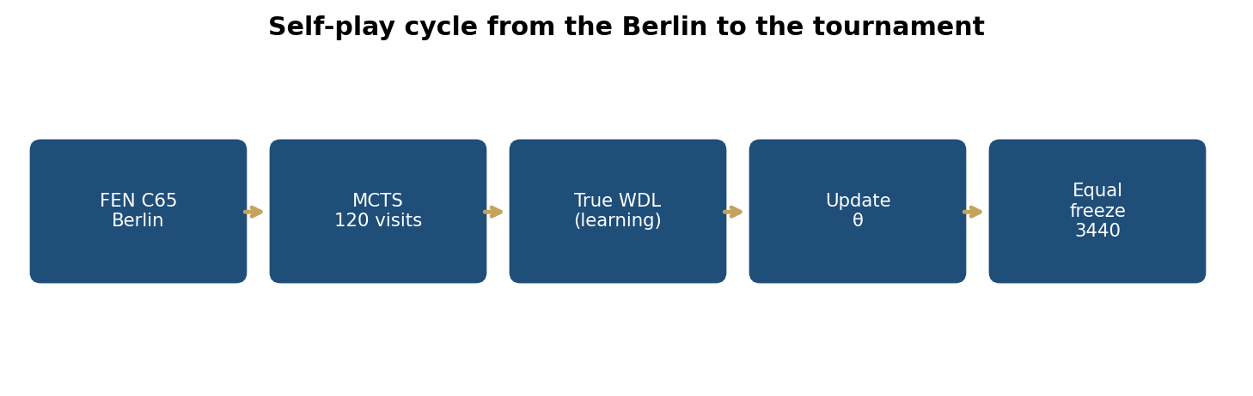
Figure 1. Self-play cycle: Berlin FEN, MCTS, weight update, tournament checkpoint.

3.3 Sample
There are no human participants. The population of interest is the games this protocol can generate from FEN C65 with the 6×64 body and 120 visits. The evaluation sample is N = 100 games per match, with fixed colours. The unit of analysis is the game from s_0 to a FIDE terminal (or adjudication at the half-move ceiling in three H3 games). The diploma corpus contains seven complete matches (700 games): three of H1/auxiliary, one of H3, three of ablation A–C. The choice of N = 100 was frozen before the scores; it is not a convenience sample of players, but a designed self-play sample. The random seed changes by match; the first eight half-moves after the Berlin have temperature τ = 1, then greedy.
This sample does not claim to represent all openings, nor full Lc0. It represents the relative comparison of three lines at this scale. The pilot match with lc0-winonly as Black and the _rep2 rematches do not enter the hypothesis sample; the criterion is the frozen protocol, not the score.

3.4 Data collection
The data are not collected from human games. They are generated by self-play: each iteration plays 8 games with MCTS (120 visits, Dirichlet noise in training); (planes, visit policy, true WDL, stm) are collected. In the standard, one Trainer over all examples; in the variant, a split by stm and two Trainers. latest.pt is saved and, according to checkpoint_every, gamesNNNNNN.pt. Comparison freeze: when every evaluation line has games003440.pt. The run_to_target script ceiling (10 000) does not move this freeze; it is a cycle ceiling, not H1’s N.
s_0 is C65. The six half-moves e4 e5 Nf3 Nc6 Bb5 Nf6 are forced, not learned. The network sees their history in 112 planes. Every tournament PGN was verified: the first six moves match this sequence and the FEN after them matches s_0. The script scripts/berlin_tournament.py rejects the game if this fails. No game was “corrected” by hand.
The storage format is PGN with headers White, Black, WhiteWeights, BlackWeights, TimeControl “120 nodes/move”, Seed, BerlinProof, WhiteQ, BlackQ. Reproducibility: the .pt weights, the tournament script, the seeds in the header.

3.5 Instruments and technical specifications
The instruments are three UCI engines written for this thesis, plus the tournament script. Internal (construct / internal) validity: equalisation of visits, of the FEN, of the 3440 weights, BerlinProof, and the WhiteQ/BlackQ headers. Measurement reliability: FIDE points are deterministic from W/D/L; the unit tests (13 / 34 / 21) protect Q, FPU and C65 identity. The tournaments were played on the same hardware, with 120 visits per move for both sides, without differing time limits. UCI contempt = off. There is no opening book beyond the six forced half-moves.
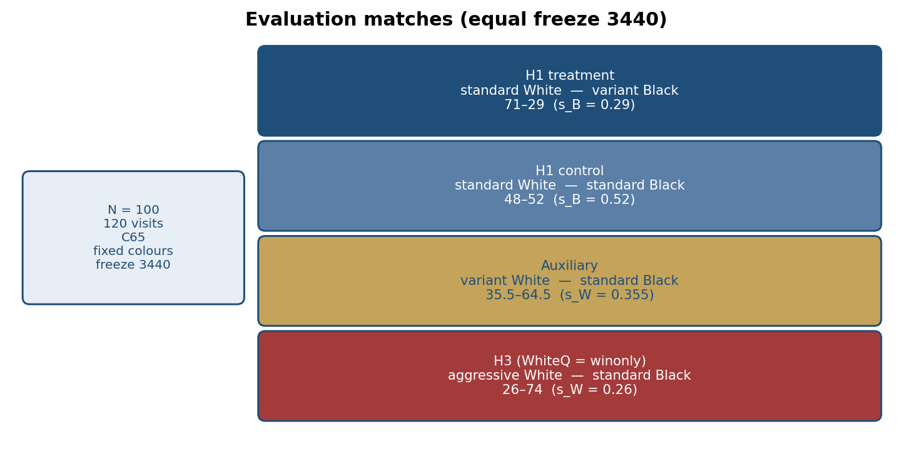
Figure 2. Evaluation matches, with fixed colours and 120 visits / move.
Table 3. Comparison of the objective functions used in this thesis.
Scheme | Win | Draw | Loss | Where it acts
Standard Q = W−L | +1 | 0 | −1 | search and learning
White DrawScore 1−2L | 1 | 1 | −1 | search Q only
Black DrawScore 2W−1 | 1 | −1 | −1 | search Q only
Q = W (H3, WhiteQ=winonly) | 1 | 0 | 0 | White search in the retained match
WDL head (all lines) | class W | class D | class L | learning, CE

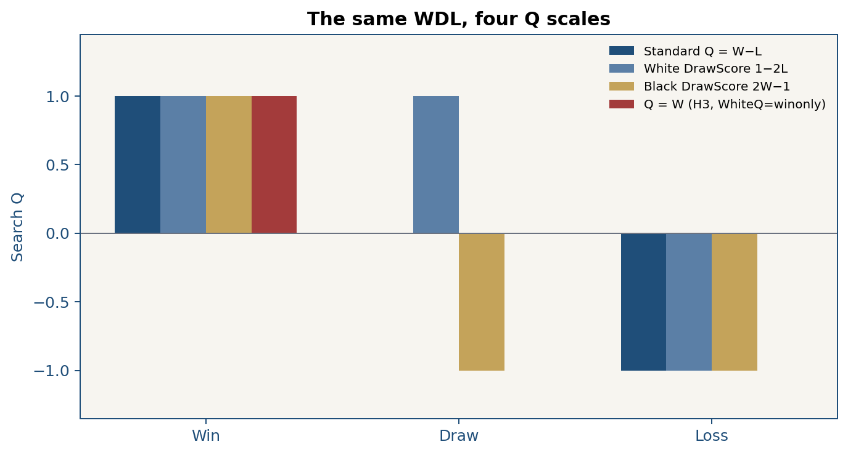
Figure 3. Classic Q (W−L), DrawScore (1−2L / 2W−1) and Q = W on the same WDL.
Table 4. ECO coding of the Berlin Defence and the thesis position FEN.
ECO code | Opening | Role in this thesis
C65 | 3…Nf6, all pieces on the board | s_0 of training and of the tournament
C66 | lines with d3 / closed | allowed if the policy chooses it
C67 | the Wall, after 8…Kxd8 | structural reference, NOT s_0

FEN of s_0: r1bqkb1r/pppp1ppp/2n2n2/1B2p3/4P3/5N2/PPPP1PPP/RNBQK2R w KQkq - 4 4
The input is 112×8×8 (INPUT_CLASSICAL_112_PLANE), with the history of the six Berlin half-moves in the tree. Body: 3×3 convolution, then 6 residual blocks with 64 channels and Squeeze-and-Excitation (16 channels). The policy head is convolutional towards 1858 Lc0 indices. The value head is WDL (softmax). A moves-left head is added. Loss: policy CE + WDL CE + 0.05 · moves-left MSE, AdamW, lr = 10⁻³.
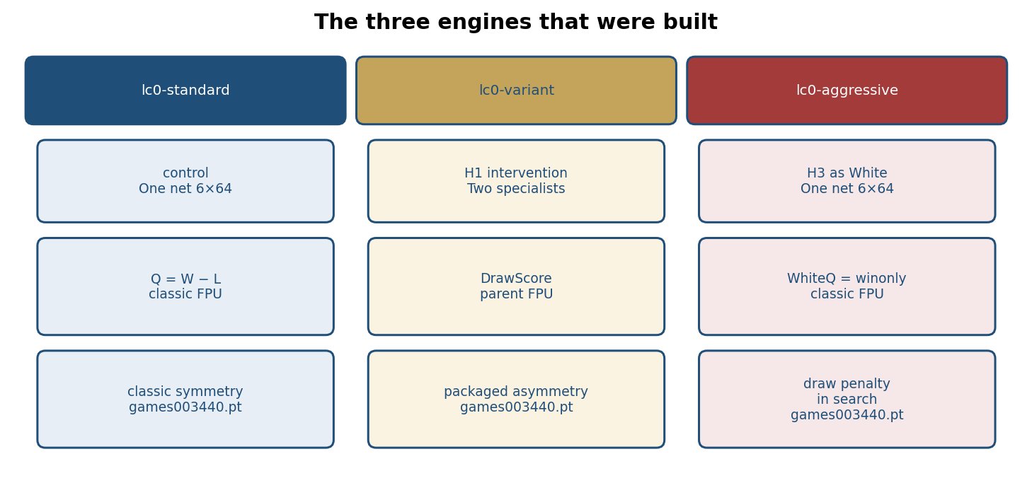
Figure 4. The three engines: lc0-standard, lc0-variant, lc0-aggressive.
lc0-standard has one network, Q = W − L, classic FPU −Q − 0.330√P. lc0-variant has two copies of the same topology after DualNetworkBackend: leaf evaluation is split by the side to move. Black’s specialist searches Q = 2W − 1; White’s specialist searches Q = 1 − 2L. FPU in the variant is parent-relative, Q − 0.330√P, because utilitarian Q is not mean-zero. lc0-aggressive again has one network and classic FPU. lc0-aggressive/configs/default.yaml remains q_mode = asymmetric (White W − L, Black Q = W); that is the q_mode of default.yaml, not the hypothesis of the saved match. In the retained match, berlin_tournament.py sets WhiteQ = winonly: draw and loss have Q = 0 for White. Folder: tournament/berlin_aggressive_white_vs_std_black_g3440.
The PUCT constants are the documented Lc0 ones (c_init = 1.745, c_base = 38739, c_factor = 3.894). Dirichlet at the root during training. Illegal-move mask before softmax. The code lives in lc0-standard/src/lc0/, lc0-variant/src/lc0/ and lc0-aggressive/src/lc0/. UCI: Lc0Berlin.exe, Lc0Berlin-Variant.exe, Lc0Berlin-Aggressive.exe. Chain: UCI go → PUCTSearch.search → backend.evaluate_cached → Node.q = search_q(...). The ablation switches only q_mode and fpu_mode on the same .pt.
Table 5. Executed hyperparameters (values frozen before the tournament).
Hyperparameter | Frozen value | Note
s_0 | FEN C65 | the same for all lines
Training / tournament visits | 120 / 120 | equal
N games / match | 100 | H1 three matches; plus aggressive as White
Temperature after the Berlin | 8 half-moves, τ=1 | then greedy
Body | 6 × 64 SE 16 | all lines
Optimiser | AdamW, lr = 10⁻³ | batch 128
Games / iteration | 8 | replay 20 000
UCI contempt | off | isolation of θ
Game budget (freeze) | 3440, equal | games003440.pt
run_to_target script ceiling | 10 000 | so the cycle can start; not H1’s N
Hardware | RTX 4060 8 GB | the same for the tournaments
2×2 ablation | same checkpoint, Q/FPU only | no retraining

Frozen H1 compares the packaged system (two networks + DrawScore + parent-relative FPU + data split) with the control. To separate the cause, the same 3440 checkpoint is evaluated again with search-only switches: q_mode ∈ {wl, drawscore} and fpu_mode ∈ {negation, parent}. The weights are not touched. Ablation White is always lc0-standard. FPU is held fixed at negation (classic) for cells A–C, so that the control cell is exactly the 48–52 match. This 2×2 does not reopen H1. Script: scripts/run_h1_ablation.py.
Table 6. The 2×2 ablation. H1 remains the last row versus the first; A–C isolate Q and the network.
Black’s network | Search Q | FPU | Status
standard (one net) | W − L | −Q − 0.330√P | H1 control, 52/100
standard (one net) | DrawScore | −Q − 0.330√P | cell A, 53/100
dual (two specialists) | W − L | −Q − 0.330√P | cell B, 44/100
dual (two specialists) | DrawScore | −Q − 0.330√P | cell C, 45/100
dual (packaged system) | DrawScore | Q − 0.330√P | H1 treatment, 29/100

3.6 Data-analysis techniques
The analysis is quantitative. The score per game is 1, ½ or 0. The main metric is the mean s and the difference Δs of two independent samples (N = 100, N = 100). The empirical standard error and the normal 95% interval give the decision of Table 8. A bootstrap with 20 000 resamples (seed 2026) was used as a check of the approximation. H2 uses a two-proportion test (decisive / not) with pooled SE. H3 uses the same Δs scheme as H1, but for White. Descriptive statistics (d, L̄, Termination, fourth move, q_ex) do not reopen H1. Software: Python, results in results.json and PGN; script scripts/analyze_tournament_pgns.py. Chapter 4 gives the full definitions.

3.7 Ethical aspects
There are no human subjects. Therefore informed consent, participant confidentiality and a right of withdrawal are not required. UNI ethical approval for the diploma topic is included in the topic proposal, as the faculty guide provides. Training was not performed on human games. The Kramnik–Kasparov 2000 PGNs are cited as history, not as data. Data integrity: games were not dropped after seeing the scores; N = 100 remained frozen; three earlier runs are kept as pilot experiments and do not enter the H1–H3 decision, because they do not meet the frozen protocol: (i) matches with τ = 0 from the first move use a different decision rule; (ii) the first standard–aggressive match swapped colours against the frozen assignment; (iii) the lc0-winonly-as-Black match is a different search package. The criterion is the protocol, not the score. The materials are submitted with the thesis, in the folder Tema-E-Diplomes: code in lc0-standard/, lc0-variant/, lc0-aggressive/ and lc0-winonly/; configurations in lc0-<engine>/configs/default.yaml; weights in lc0-<engine>/checkpoints/run10k/<engine>-games003440.pt; PGNs, results.json and the Seed header in tournament/, for example tournament/berlin_std_white_vs_var_black_g3440 and tournament/berlin_aggressive_white_vs_std_black_g3440. There is no external repository; this folder is the submitted source. The use of auxiliary tools for editing does not replace the student’s responsibility for the FEN, for APA 7 citation and for the numbers in Table 9. There is no conflict of interest and no external funding. Negative findings are reported; there is no selective reporting of H1.

3.8 Methodological limitations
No methodology is perfect. The RTX 4060 forced the 6×64 body, the 120 visits and the 3440 freeze. N = 100 is enough for Δs = −0.23, but is small for dual-net effects that cross zero. The H1 treatment is a package, not one scalar; the ablation without retraining separates search, not learned θ. lc0-aggressive default.yaml remains q_mode = asymmetric; H3 is a search evaluation of the checkpoint as White with WhiteQ = winonly. The field is one opening. These limitations are justified by feasibility in bachelor time and by equalisation of the lines; they are not hidden. Chapter 7 restates them.

3.9 Chapter summary
The study is quantitative-experimental, with a sample of N = 100 games generated from C65, three UCI instruments, collection from self-play, analysis with Δs and a 95% interval, and no human subjects. Chapter 4 specifies the metrics; Chapter 5 reports the findings.

Chapter 4: Data analysis
This chapter describes the evaluation corpus and how the metrics are computed, before Chapter 5 reports the findings. It does not interpret the results.

4.1 Primary data
The unit is the game from s_0 to a FIDE terminal (checkmate, stalemate, fifty moves, threefold, insufficient material) or, in three H3 games, adjudication at the half-move ceiling. N = 100 per match. The diploma corpus contains seven complete matches (700 games): (i) H1 treatment, standard White — variant Black; (ii) H1 control, standard — standard; (iii) auxiliary, variant White — standard Black; (iv) retained H3, aggressive White — standard Black; (v–vii) three ablation matches A–C. All with berlin_ok = true and weights games003440.pt. Greedy matches (τ = 0) and the colour-swapped lc0-aggressive match are not included. The pilot match with lc0-winonly as Black is outside hypotheses H1–H3.
The main control is the match standard (White) — standard (Black). The H1 treatment is standard (White) — variant (Black). The third match, variant (White) — standard (Black), tests asymmetric White against the same standard Black. Colours are fixed: both H1 Blacks have the same first-move disadvantage.
After H1, the style analysis is descriptive and does not reopen the decision. It uses the PGN Termination header, the fourth move (SAN), and two definitions of q_ex: (a) reaching the exact C67 FEN, (b) occurrence of Qxd8+ in the game. Many fifty-move games indicate low absolute strength. A style that “looks sharp” does not replace points (Elo, 1978; McIlroy-Young et al., 2020).

4.2 Metrics and confidence intervals
Main: s = (W + 0.5 D)/N of the tested side, Δs, W/D/L. Auxiliary: d = D/N, 1−d, mean game length, approximate Elo 400 log10(s/(1−s)) only as a note. Δs was estimated as the difference of two independent mean scores per game (N = 100, N = 100). Empirical variance gave SE ≈ 0.052, z ≈ -4.44, normal 95% CI [-0.332, -0.128]. A bootstrap with 20 000 resamples (seed 2026) gave the interval [−0.330, −0.130], in agreement with the normal approximation. The decision follows Table 8. Games after eight half-moves with temperature are only partly independent; this makes the SE a lower bound on uncertainty, not a full model of the opening.
Table 7. Tournament metrics and their definition.
Metric | Definition | Role
s | Mean score (1 / ½ / 0) | H1
W, D, L | Wins, draws, losses | H1
Δs | s_var − s_std (as Black) | decision
ΔElo | 400 log10(s/(1−s)), approximate | auxiliary
d = D/N | draw rate | H2
1 − d | decisive games | H2
L̄ | mean half-moves | auxiliary

Table 8. Decision rule for H1 — applied without change.
Condition (frozen before the tournament) | Decision
Lower 95% bound of Δs > 0 | H1 supported
Upper 95% bound of Δs < 0 | H1 rejected (harm)
0 included in the interval | undecided; not success
Change of N, FEN, visits after seeing scores | H1 invalid

4.2.1 Assumptions of the statistical tests
H1 and H3 use a normal 95% interval for the difference of two independent means. The unit is the game score in {0, ½, 1}. For N = 100, the central limit theorem makes the mean s approximately normal; that justifies z and the interval, not a paired t, because the two matches are not pairs of the same games. H1 is directional (s_var > s_std), but the interval and the z test are two-sided: that is more conservative than a one-sided test and does not change the decision, because the entire interval is < 0. Games after eight half-moves with temperature share the C65 prefix and are only partly independent; the empirical SE is therefore a lower bound on uncertainty. The bootstrap with 20 000 resamples (seed 2026) was used as a check of the normal approximation. H2 uses a two-proportion test with pooled SE. Effect size is reported in the decision unit, Δs (points / game); z is the standardised form. No regression or ANCOVA was used: there are no human covariates.

4.3 Chapter summary
The retained corpus has 700 games from C65, N = 100 per match, weights 3440. The decision metric is Δs with a 95% interval. Chapter 5 reports the values; Chapter 6 interprets them.

Chapter 5: Results
This chapter presents the findings of the seven matches, without interpretation. Interpretation is given in Chapter 6. The organisation follows the hypotheses: H1, H2, H3, then the ablation and descriptive statistics. Sample characteristics: 700 generated games, all from FEN C65, berlin_ok = true, weights games003440.pt, 120 visits / move, N = 100 per match, eight half-moves with τ = 1 then greedy. There are no human demographic data; the unit is the game, not the player. Every game starts 1.e4 e5 2.Nf3 Nc6 3.Bb5 Nf6.

5.1 H1: Black’s score
Table 9. Main tournament. W/D/L are from the viewpoint of the first-named side. The Elo column is a 400 log10(s/(1−s)) note, unstable at the edges (s ≈ 0.26–0.29); the decision follows Δs and Table 8, not Elo.
Match (fixed colours) | N | W | D | L | s | Approx. Elo
variant Black — standard White | 100 | 14 | 30 | 56 | 0.290 | -156
standard Black — standard White | 100 | 29 | 46 | 25 | 0.520 | +14
Δs (H1) = 0.290 − 0.520 | 100 | — | — | — | −0.230 | ≈ -169
95% CI of Δs (H1) | — | — | — | — | [-0.332, -0.128] | z ≈ -4.44
variant White — standard Black | 100 | 20 | 31 | 49 | 0.355 | -104
standard White — standard Black | 100 | 25 | 46 | 29 | 0.480 | -14
aggressive White — standard Black | 100 | 11 | 30 | 59 | 0.260 | -182
Δs (H3, as White) = 0.260 − 0.480 | 100 | — | — | — | −0.220 | ≈ -168
95% CI of Δs (H3) | — | — | — | — | [-0.319, -0.121] | z ≈ -4.36

For H1, s_var = 0.290 and s_std = 0.520, Δs = −0.230, 95% CI [-0.332, -0.128], z ≈ -4.44. The upper bound of the interval is < 0. According to Table 8, H1 is rejected. Figure 5 and Figure 6 show Black’s score and WDL.
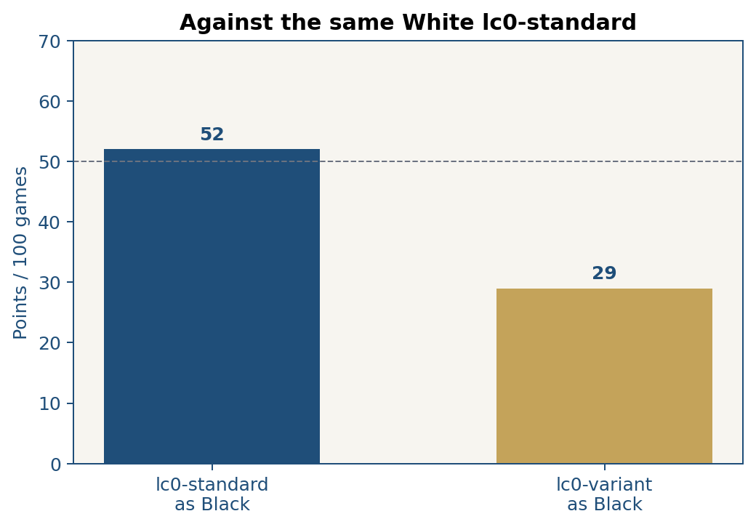
Figure 5. Black’s score against the same White lc0-standard.
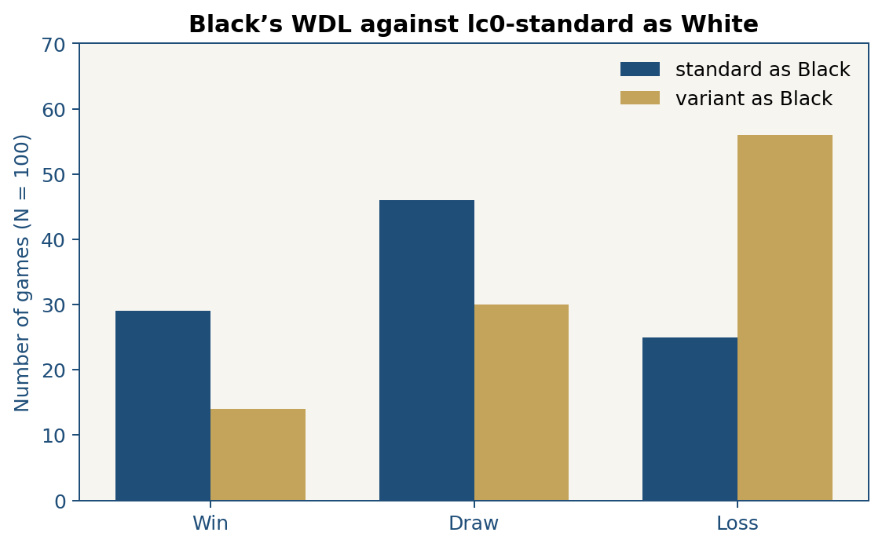
Figure 6. Black’s WDL: 14–30–56 (variant) versus 29–46–25 (standard).
Table 10. Search visits were kept 120/120; 64 and 256 were not varied.
Choice | Frozen value | Why
Visits in training | 120 | equal to the tournament
Visits in the tournament | 120 | H1 does not change search depth
Variation 64 / 256 | not done | would confound budget with objective

5.2 H2: decisive games
Table 11. Draws, decisions, mean length and Wall entry (q_ex). Exact C67: 0/100 in all four matches.
Match | d = D/N | 1 − d | L̄ (half-moves) | q_ex
variant Black — standard White | 0.30 | 0.70 | 209 | 0 / 100 C67; 1× Qxd8
standard Black — standard White | 0.46 | 0.54 | 157 | 0 / 100 C67; 0× Qxd8
variant White — standard Black | 0.31 | 0.69 | 174 | 0 / 100 C67; 0× Qxd8
aggressive White — standard Black | 0.30 | 0.70 | 222 | 0 / 100 C67; 0× Qxd8

For H2, the decisive rate of the variant as Black is 0.70; of the control 0.54. The difference is 0.16. Two-proportion test: z ≈ 2.33, p ≈ 0.020, 95% confidence interval of the difference [0.027, 0.293]. H2 was supported. FEN C67: 0/100 in all four matches of Table 11.

5.3 H3: lc0-aggressive as White
This match is not H1. In the PGN, WhiteQ = winonly. Result: 11 wins, 30 draws, 59 losses, s = 0.26. Standard White control against the same Black: s = 0.48. Δs = −0.22, 95% CI [-0.319, -0.121], z ≈ -4.36. Variant as White: s = 0.355. L̄ ≈ 222 half-moves. Three games end by adjudication (max_game_ply = 512).
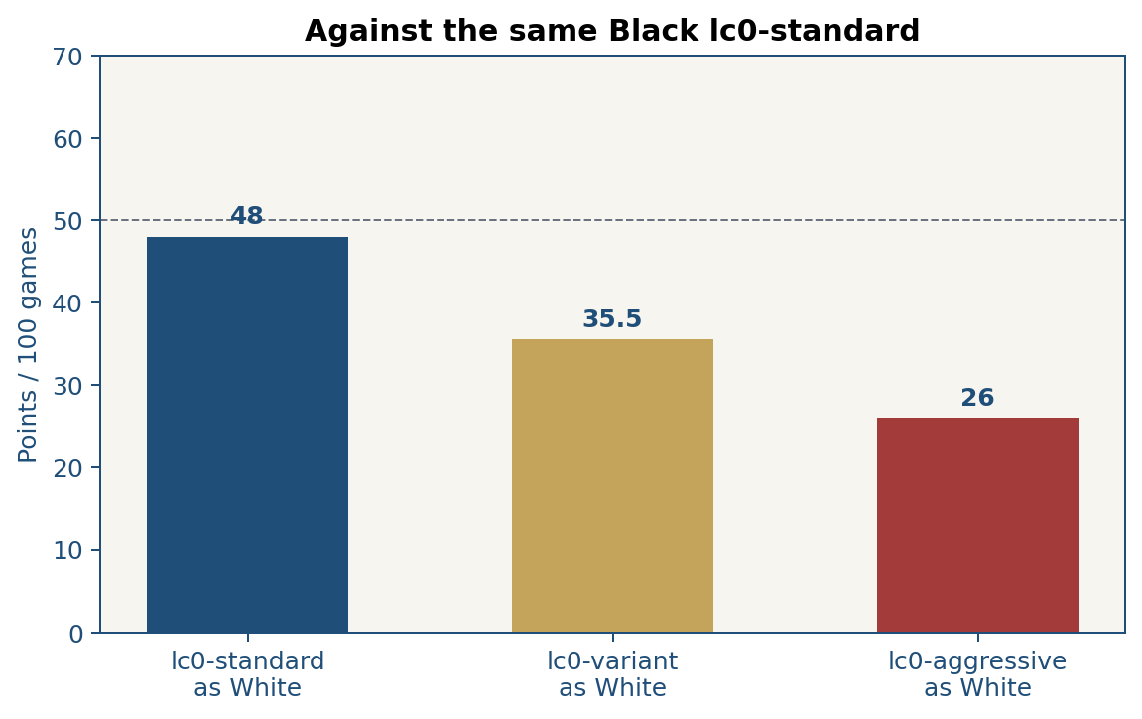
Figure 7. White’s score against the same Black lc0-standard.

5.4 The 2×2 ablation
Table 12. Search ablation, N = 100, White fixed as lc0-standard.
Cell | Black (search) | Points /100 | W | D | L
control | standard + W−L | 52 | 29 | 46 | 25
A | standard + DrawScore | 53 | 39 | 28 | 33
B | dual + W−L | 44 | 29 | 30 | 41
C | dual + DrawScore, classic FPU | 45 | 29 | 32 | 39
H1 | dual + DrawScore + parent FPU | 29 | 14 | 30 | 56

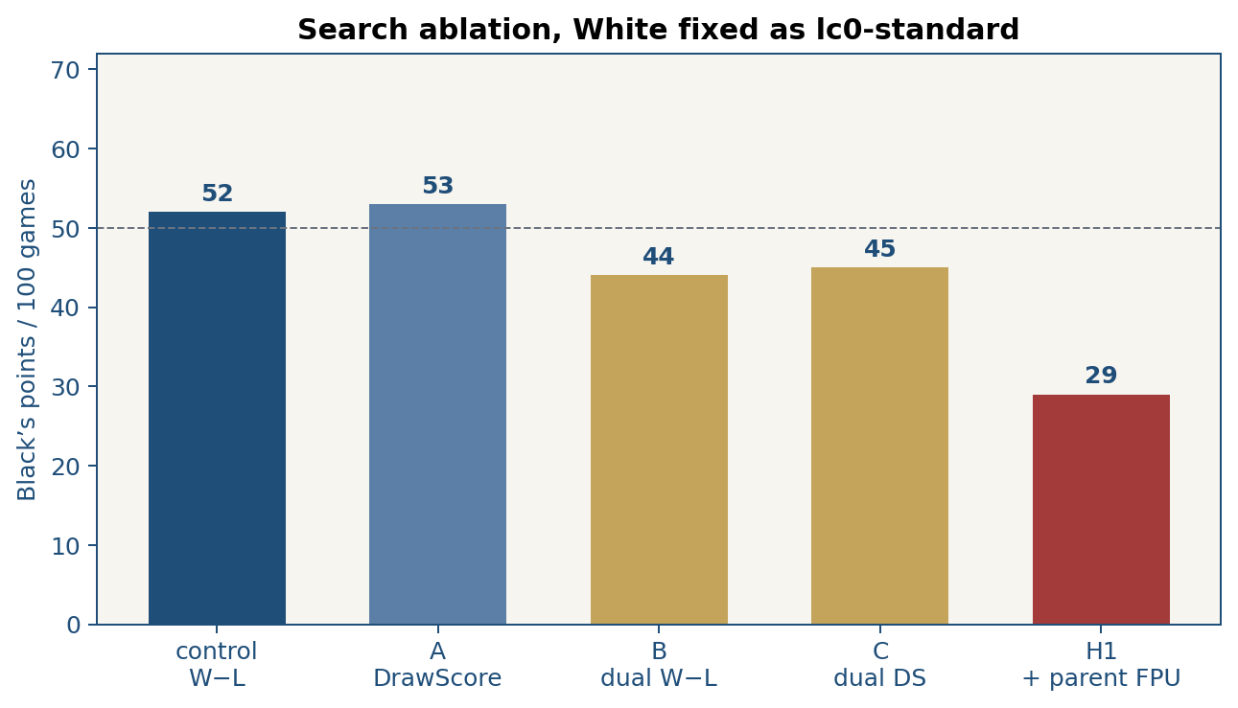
Figure 8. Black’s score in the ablation cells, N = 100.
Cell A = 53, control = 52, Δs = +0.01, 95% CI [−0.100, +0.120]. Cell B = 44, CI of B−control [−0.189, +0.029]. Cell C = 45, CI of C−control [−0.178, +0.038]. C − B = +0.01. H1 = 29 versus C = 45: Δs = −0.16, 95% CI [−0.268, −0.052], z ≈ −2.91.

5.5 Descriptive statistics
Table 13. Termination mode (Termination header). The first three columns: H1 plus the auxiliary (300 games); the fourth: H3. Three “adjudication” games in H3 (max_game_ply = 512).
Termination (FIDE / python-chess) | stdW–varB | stdW–stdB | varW–stdB | aggW–stdB
Checkmate | 70 | 54 | 69 | 70
Fifty moves | 22 | 8 | 3 | 21
Threefold repetition | 2 | 22 | 17 | 2
Insufficient material | 5 | 15 | 10 | 4
Stalemate | 1 | 1 | 1 | 0
Adjudication (max-ply) | 0 | 0 | 0 | 3

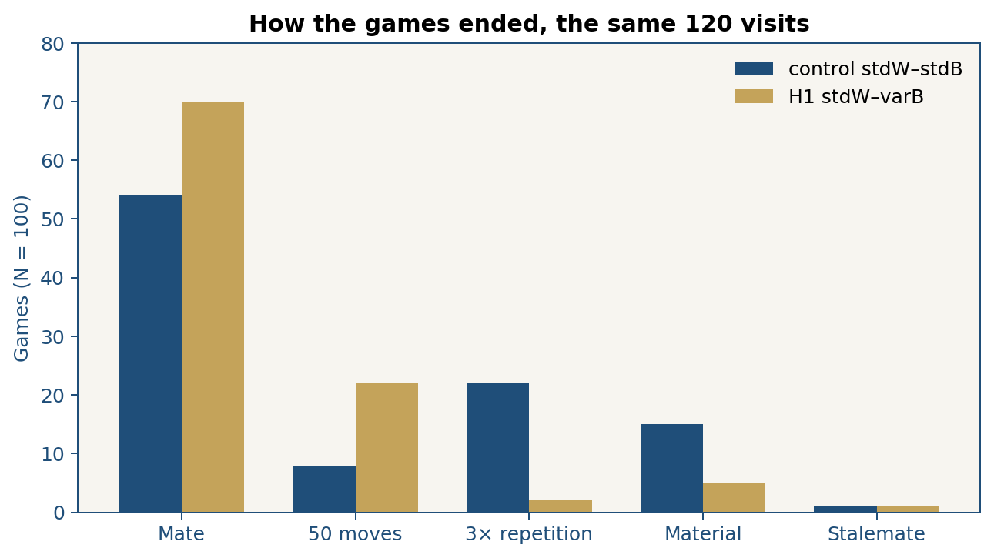
Figure 9. Termination by Termination header, four matches.
Descriptive statistic required by the guide: the termination mode in stdW–varB is checkmate; in the stdW–stdB control checkmate remains the most frequent, but threefold repetition rises (22 versus 2). The range of the score per game is {0, ½, 1} in every match. Mean s is reported in Table 9; it is not interpreted here.
Table 14. Frequency of White’s fourth move (SAN), N = 100 per column.
White’s fourth move | stdW–stdB | stdW–varB | varW–stdB | aggW–stdB
Nd4 | 30 | 38 | 0 | 10
h4 | 21 | 17 | 4 | 7
c4 | 18 | 14 | 0 | 3
O-O | 2 | 2 | 3 | 0
Nh4 | 0 | 0 | 0 | 19
g3 | 1 | 0 | 0 | 12
Ke2 | 0 | 0 | 3 | 11
c3 | 1 | 3 | 18 | 0
d4 | 0 | 0 | 17 | 0
Nc3 | 0 | 0 | 15 | 3

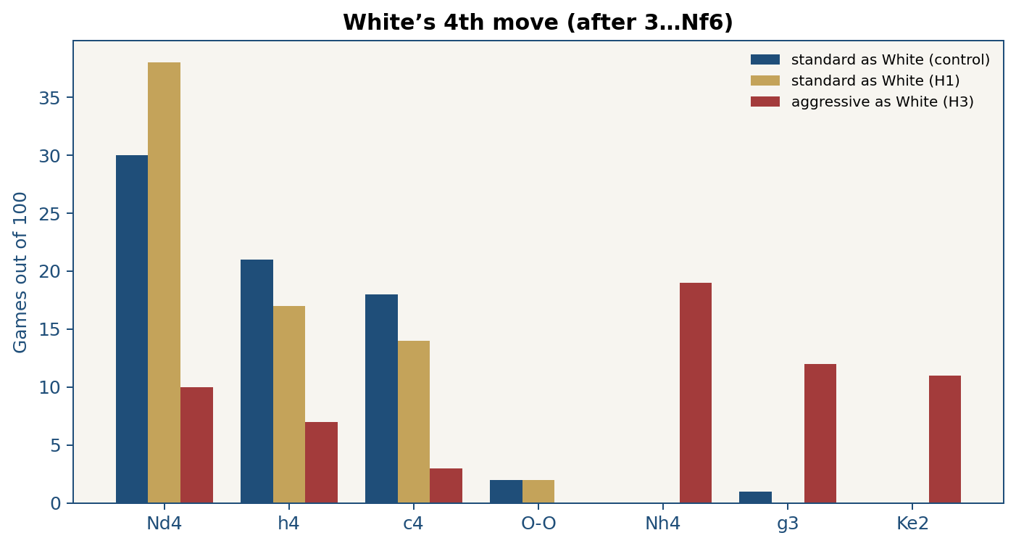
Figure 10. Fourth move: lc0-standard as White (Nd4/h4/c4) and lc0-aggressive (Nh4/g3/Ke2).
4.O-O: 2/100 (stdW–stdB), 2/100 (stdW–varB), 3/100 (varW–stdB), 0/100 (aggW–stdB). For aggressive as White: Nh4 19/100, g3 12/100, Ke2 11/100. FEN C67: 0/100.

5.6 Summary of findings
H1: Δs = −0.23, CI entirely < 0, H1 rejected. H2: 70% decisive versus 54%, z ≈ 2.33, p ≈ 0.020, 95% CI [0.027, 0.293]; H2 was supported. H3: s_W = 0.26 versus 0.48. Ablation: A 53, B 44, C 45, H1 29. C67: 0/100. Chapter 6 interprets these values.

Chapter 6: Discussion and conclusions

6.1 Introduction to the discussion
The research question was whether changing search Q during self-play raises specialist Black’s score in Berlin C65. H0: s_var ≤ s_std. H1: s_var > s_std. H2 predicted more decisive games for the variant as Black. H3, labelled, asked whether Q = W as White raises the score against the same Black. This chapter interprets the findings of Chapter 5, relates them to the literature, and gives implications, recommendations and the conclusion. It does not repeat the tables.
Main findings, summarised: asymmetric Black 29/100 versus 52/100 (Δs = −0.23); as White, 48 / 35.5 / 26; ablation A 53, B 44, C 45.

6.2 Interpretation of the results
According to Table 8, H1 is rejected in the direction of harm: the upper bound of the 95% CI is -0.128 < 0. Asymmetric Black took 23 points fewer out of 100. H2 was supported: more decisive games (70% versus 54%, z ≈ 2.33, p ≈ 0.020, 95% CI [0.027, 0.293]). The combination ¬H1 ∧ H2 reads: the package increased sharpness (fewer draws), but turned it into losses, not wins. Table 13 reinforces this: in H1, checkmates and the fifty-move rule increase, not the repetition that characterises the control.
The same direction is seen for White: the variant 35.5/100 versus the standard 48/100. lc0-aggressive as White, with WhiteQ = winonly, scored 26/100. The standard–standard match 48–52 is close to equality, so the control is not a broken side. The failure of H1 remains that of the packaged system; H3 shows that punishing the draw in search, placed on White, does not raise the score at this scale. The ablation narrows the cause: DrawScore alone (cell A) does not produce 29/100; the parent-relative FPU contrast (H1 versus C) excludes zero.
q_ex = 0 and rare 4.O-O show that the analogy with Kramnik’s Berlin endgame (Kramnik & Kasparov, 2000; Tomašev et al., 2022) remains a motive, not a description of learned π. Nd4/h4/c4 in lc0-standard and Nh4/g3/Ke2 in lc0-aggressive, with 120 visits, are a symptom of the shallow net. H1 still compares two lines at the same scale; it does not compare two masters of C67 theory.
Reasonableness from the literature is not enough (Silver et al., 2017b; Leela Chess Zero, 2023; Tomašev et al., 2022; Lawson, 2018). π depends on the search objective and on who learns from which positions. In the variant, the White and Black specialists learn from the same games, but from half of the positions. If the White specialist becomes too “closing”, Black does not see wins; if it becomes weak, Black learns cheap tactics that the standard punishes. Learned overplay in θ remains possible; the ablation without retraining does not measure that part.

6.3 Relation to the literature
The result does not reject Lc0 v0.30 contempt as a search tool over a mature network. It rejects, at this scale, the claim that freezing DrawScore plus dual-net plus parent-relative FPU during 6×64 self-play from the Berlin raises Black’s score. Silver et al. (2017b) left z symmetric; this thesis changed search Q and measured the consequence. Tomašev et al. (2022) describe the Berlin as a structure that engines have revalued; this thesis’s 120-visit engines did not even reach FEN C67, so the analogy with Kramnik remains a motive. Howell (2018) and Lawson (2018) noted the rigidity of AlphaZero’s style; here rigidity was replaced by a more decisive style that loses points.
Maia (McIlroy-Young et al., 2020) shows that θ follows the function it is given. Here the packaged Q function did not raise s. The league literature (Berner et al., 2019; Zahavy et al., 2023) justifies a not-you partner; it does not guarantee that two 6×64 specialists with 3440 games are stronger than a single net. The contribution to the field is controlled negative evidence: search asymmetry during self-play, in this protocol, failed as an improvement of the FIDE score.

6.4 Implications
For engines with limited resources, the cheaper intervention if sharpness is desired remains contempt in search over a classical θ, not retraining the sides with frozen DrawScore. For RL research in chess, the result underlines that changing Q during self-play is testable and that a reasonable hypothesis can fail at a shallow scale. A bachelor thesis can defend a frozen negative finding, without rewriting the title as a success.
The restriction to C65 raises internal power and lowers external validity. A θ that fails in the Berlin may behave differently in the Sicilian; that was not measured. The 3440 budget is the frozen comparison stop; it is not claimed as maturity of a 6×64 against full Lc0. The Δs of this protocol is not extrapolated to the script’s 10 000 ceiling. The full limitations are in Chapter 7.

6.5 Recommendations for future research
Future work after this 2×2: (1) retraining with classic FPU, so that harm learned in θ is isolated from search FPU; (2) sensitivity to d_s ∈ {−0.5, 0, +0.5}; (3) N ≥ 200 for dual-net effects that here cross zero; (4) tournament visits 400–800; (5) a transfer test against Stockfish, labelled as such, not as H1. The training script’s 10 000 ceiling is not a scientific objective.

6.6 Conclusion
The question was whether packaged search asymmetry during self-play raises Black’s score in the Berlin. Alternative hypothesis H1 was rejected: 29/100 versus 52/100, Δs = −0.23, 95% CI [-0.332, -0.128]. H2 was supported without extra points. H3, Q = W as White, gave 26/100 versus 48/100. In this protocol, the classical reward structure performed better.
Implication: changing Q during self-play is testable; at scale 6×64 / 120 visits / 3440 games, the package DrawScore + dual-net + parent-relative FPU harmed the FIDE score. The practical recommendation, within these bounds, is contempt over a classical θ, not retraining the sides with frozen DrawScore. The limitations — one opening, one card, N = 100, package not scalar, yaml vs WhiteQ — remain declared. Future studies should isolate FPU with retraining and label any transfer test.
Closing conclusion: the aims of self-play can be changed in a controlled way, and a reasonable hypothesis can fail. This thesis documents the failure, not an Elo record.

Chapter 7: Limitations

7.1 Computational resources
Training and the tournaments were run on an RTX 4060 graphics card with 8 GB VRAM. This set limits on the 6×64 body, the 120 visits and the 3440 freeze. With larger resources a deeper network or more tournament visits would have been possible.

7.2 Sample size and opening
N = 100 is enough for Δs = −0.23 (the CI does not cross zero), but is small for dual-net effects that cross zero in cells B and C. A larger N remains desirable for small effects, not necessary for H1. The field is only Berlin C65. Absolute strength is low; the relative comparison remains valid within the scale. Independence of the games is more limited than a usual N = 100 suggests: all 100 games in a match start from the same C65 FEN and play with the same games003440.pt weights. Temperature τ = 1 on the first eight half-moves adds variation, but the shared prefix and the shared checkpoint link the games. The standard error and the 95% interval are therefore a lower bound on uncertainty, not a full measure of it.

7.3 Identification and validity
The H1 treatment changes more than one scalar r (Q × dual-net × FPU). The search ablation split the bundle without retraining: DrawScore alone does not explain 29/100; dual with classic FPU is undecided at 95%; parent-relative FPU, with dual and DrawScore fixed, Δs = −0.16 versus cell C, 95% CI [−0.268, −0.052]. No network was retrained for this 2×2; harm learned in θ remains unseen. Internal: the visit budget was equalised; s_0 was equalised; the weights are 3440 for the compared lines; contempt off. External: one opening, one scale. Construct: Δs measures the desired consequence of style, not “beauty”. Reproducibility: the tournament script, PGN, weights; seeds and WhiteQ are in the header. N was not changed after seeing the scores. For H3: lc0-aggressive default.yaml remains q_mode = asymmetric; the retained match overrides White’s search with WhiteQ = winonly. Therefore H3 is a search evaluation of the 3440 checkpoint as White, not a claim that self-play of θ_agg used Q = W for both colours.

References
Berner, C., Brockman, G., Chan, B., Cheung, V., Dębiak, P., Dennison, C., Farhi, D., Fischer, Q., Hashme, S., Hesse, C., Józefowicz, R., Gray, S., Olsson, C., Pachocki, J., Petrov, M., Pinto, H. P. d. O., Raiman, J., Salimans, T., Schlatter, J., Schneider, J., Sidor, S., Sutskever, I., Tang, J., Wolski, F., & Zaremba, W. (2019). Dota 2 with large scale deep reinforcement learning. arXiv. https://arxiv.org/abs/1912.06680
Browne, C. B., Powley, E., Whitehouse, D., Lucas, S. M., Cowling, P. I., Rohlfshagen, P., Tavener, S., Perez, D., Samothrakis, S., & Colton, S. (2012). A survey of Monte Carlo tree search methods. IEEE Transactions on Computational Intelligence and AI in Games, 4(1), 1–43. https://doi.org/10.1109/TCIAIG.2012.2186810
Campbell, M., Hoane, A. J., Jr., & Hsu, F.-h. (2002). Deep Blue. Artificial Intelligence, 134(1–2), 57–83. https://doi.org/10.1016/S0004-3702(01)00129-1
Coulom, R. (2008). Whole-history rating: A Bayesian rating system for players of time-varying strength. In H. J. van den Herik, X. Xu, Z. Ma, & M. H. M. Winands (Eds.), Computers and games (pp. 113–124). Springer. https://doi.org/10.1007/978-3-540-87608-3_11
Cox, J. (2008). The Berlin Wall. Quality Chess.
Edwards, S. J. (1994, March 12). Standard: Portable Game Notation specification and implementation guide. https://github.com/fsmosca/PGN-Standard/blob/master/PGN-Standard.txt
Elo, A. E. (1978). The rating of chessplayers, past and present. Arco.
FIDE. (2023). FIDE laws of chess. https://handbook.fide.com/
Heinrich, J., & Silver, D. (2016). Deep reinforcement learning from self-play in imperfect-information games. arXiv. https://arxiv.org/abs/1603.01121
Howell, D. (2018, December 9). Chess column on the consultative match against AlphaZero (Berlin Defence). The Sunday Times.
Jaderberg, M., Dalibard, V., Osindero, S., Czarnecki, W. M., Donahue, J., Razavi, A., Vinyals, O., Green, T., Dunning, I., Simonyan, K., Fernando, C., & Kavukcuoglu, K. (2017). Population based training of neural networks. arXiv. https://arxiv.org/abs/1711.09846
Knuth, D. E., & Moore, R. W. (1975). An analysis of alpha-beta pruning. Artificial Intelligence, 6(4), 293–326. https://doi.org/10.1016/0004-3702(75)90019-3
Kocsis, L., & Szepesvári, C. (2006). Bandit based Monte-Carlo planning. In J. Fürnkranz, T. Scheffer, & M. Spiliopoulou (Eds.), Machine learning: ECML 2006 (pp. 282–293). Springer. https://doi.org/10.1007/11871842_29
Kramnik, V., & Kasparov, G. (2000). Braingames World Chess Championship, London [PGN]. Chessgames. https://www.chessgames.com/perl/chess.pl?tid=61813
Lai, M. (2015). Giraffe: Using deep reinforcement learning to play chess [Master’s thesis, Imperial College London]. arXiv. https://arxiv.org/abs/1509.01549
Lanctot, M., Lockhart, E., Lespiau, J.-B., Zambaldi, V., Upadhyay, S., Pérolat, J., Srinivasan, S., Timbers, F., Tuyls, K., Omidshafiei, S., Hennes, D., Morrill, D., Muller, P., Ewalds, T., Faulkner, R., Kramár, J., Vylder, B. D., Saeta, B., Bradbury, J., … Pietquin, O. (2019). OpenSpiel: A framework for reinforcement learning in games. arXiv. https://arxiv.org/abs/1908.09453
Lawson, D. (2018, December 9). Dominic Lawson v AlphaZero: What beauty in being the new chess god’s first sacrifice. The Sunday Times. https://www.thetimes.com/business/technology/article/dominic-lawson-how-i-lost-to-chess-program-alphazero-zs5vkmlzw
Lunenburg, F. C., & Irby, B. J. (2008). Writing a successful thesis or dissertation: Tips and strategies for students in the social and behavioral sciences. Corwin Press.
Leela Chess Zero. (n.d.-a). Developer documentation: Architecture, search, network topology. https://lczero.org/dev/
Leela Chess Zero. (n.d.-b). Classic search: GetDrawScore and Q = wl + draw_score × d [Source code]. GitHub. https://github.com/LeelaChessZero/lc0/blob/master/src/search/classic/search.cc
Leela Chess Zero. (2019). Train not only from startpos (Issue #787). GitHub. https://github.com/LeelaChessZero/lc0/issues/787
Leela Chess Zero. (2023, July). The Lc0 v0.30.0 WDL rescale/contempt implementation. https://lczero.org/blog/2023/07/the-lc0-v0.30.0-wdl-rescale-contempt-implementation/
McGrath, T., Kapishnikov, A., Tomašev, N., Pearce, A., Hassabis, D., Kim, B., Paquet, U., & Kramnik, V. (2022). Acquisition of chess knowledge in AlphaZero. Proceedings of the National Academy of Sciences, 119(47), e2206625119. https://doi.org/10.1073/pnas.2206625119
McIlroy-Young, R., Sen, S., Kleinberg, J., & Anderson, A. (2020). Aligning superhuman AI with human behavior: Chess as a model system. In Proceedings of the 26th ACM SIGKDD Conference on Knowledge Discovery and Data Mining (pp. 1677–1687). ACM. https://doi.org/10.1145/3394486.3403219
Mnih, V., Kavukcuoglu, K., Silver, D., Rusu, A. A., Veness, J., Bellemare, M. G., Graves, A., Riedmiller, M., Fidjeland, A. K., Ostrovski, G., Petersen, S., Beattie, C., Sadik, A., Antonoglou, I., King, H., Kumaran, D., Wierstra, D., Legg, S., & Hassabis, D. (2015). Human-level control through deep reinforcement learning. Nature, 518(7540), 529–533. https://doi.org/10.1038/nature14236
Naphthalin. (2023). WDL conversion for more realistic WDL and contempt (Pull request #1791). GitHub. https://github.com/LeelaChessZero/lc0/pull/1791
Nasu, Y. (2018). Efficiently updatable neural-network-based evaluation functions for computer shogi. https://github.com/ynasu87/nnue/blob/master/docs/nnue.pdf
Newell, A., Shaw, J. C., & Simon, H. A. (1958). Chess-playing programs and the problem of complexity. IBM Journal of Research and Development, 2(4), 320–335. https://doi.org/10.1147/rd.24.0320
python-chess. (n.d.). A chess library for Python. https://python-chess.readthedocs.io/
Sadler, M. (2024, February 28). Getting Leela to analyse and play in the style you want! Part 1: Setting up WDL contempt. https://matthewsadler.me.uk/engine-chess/setting-up-wdl-contempt-for-leela-in-nibbler/
Sadler, M., & Regan, N. (2019). Game changer: AlphaZero’s groundbreaking chess strategies and the promise of AI. New in Chess.
Schrittwieser, J., Antonoglou, I., Hubert, T., Simonyan, K., Sifre, L., Schmitt, S., Guez, A., Lockhart, E., Hassabis, D., Graepel, T., Lillicrap, T., & Silver, D. (2020). Mastering Atari, Go, chess and shogi by planning with a learned model. Nature, 588(7839), 604–609. https://doi.org/10.1038/s41586-020-03051-4
Schulman, J., Wolski, F., Dhariwal, P., Radford, A., & Klimov, O. (2017). Proximal policy optimization algorithms. arXiv. https://arxiv.org/abs/1707.06347
Shannon, C. E. (1950). Programming a computer for playing chess. Philosophical Magazine, 41(314), 256–275. https://doi.org/10.1080/14786445008521796
Silver, D., Huang, A., Maddison, C. J., Guez, A., Sifre, L., van den Driessche, G., Schrittwieser, J., Antonoglou, I., Panneershelvam, V., Lanctot, M., Dieleman, S., Grewe, D., Nham, J., Kalchbrenner, N., Sutskever, I., Lillicrap, T., Leach, M., Kavukcuoglu, K., Graepel, T., & Hassabis, D. (2016). Mastering the game of Go with deep neural networks and tree search. Nature, 529(7587), 484–489. https://doi.org/10.1038/nature16961
Silver, D., Schrittwieser, J., Simonyan, K., Antonoglou, I., Huang, A., Guez, A., Hubert, T., Baker, L., Lai, M., Bolton, A., Chen, Y., Lillicrap, T., Hui, F., Sifre, L., van den Driessche, G., Graepel, T., & Hassabis, D. (2017a). Mastering the game of Go without human knowledge. Nature, 550(7676), 354–359. https://doi.org/10.1038/nature24270
Silver, D., Hubert, T., Schrittwieser, J., Antonoglou, I., Lai, M., Guez, A., Lanctot, M., Sifre, L., Kumaran, D., Graepel, T., Lillicrap, T., Simonyan, K., & Hassabis, D. (2017b). Mastering chess and shogi by self-play with a general reinforcement learning algorithm. arXiv. https://arxiv.org/abs/1712.01815 (also Silver, D., Hubert, T., Schrittwieser, J., Antonoglou, I., Lai, M., Guez, A., Lanctot, M., Sifre, L., Kumaran, D., Graepel, T., Lillicrap, T., Simonyan, K., & Hassabis, D. (2018). A general reinforcement learning algorithm that masters chess, shogi, and Go through self-play. Science, 362(6419), 1140–1144. https://doi.org/10.1126/science.aar6404)
Stockfish developers. (n.d.). Stockfish NNUE and Fishtest / SPRT. https://stockfishchess.org/
Sutton, R. S., & Barto, A. G. (2018). Reinforcement learning: An introduction (2nd ed.). MIT Press.
Tesauro, G. (1995). Temporal difference learning and TD-Gammon. Communications of the ACM, 38(3), 58–68. https://doi.org/10.1145/203330.203343
Tomašev, N., Paquet, U., Hassabis, D., & Kramnik, V. (2022). Reimagining chess with AlphaZero. Communications of the ACM, 65(2), 60–67. https://doi.org/10.1145/3460349
UNI-Universum International College. (n.d.). Udhëzuesi për punimin e diplomës. Internal faculty document.
Vinyals, O., Babuschkin, I., Czarnecki, W. M., Mathieu, M., Dudzik, A., Chung, J., Choi, D. H., Powell, R., Ewalds, T., Georgiev, P., Oh, J., Horgan, D., Kroiss, M., Danihelka, I., Huang, A., Sifre, L., Cai, T., Agapiou, J. P., Jaderberg, M., … Silver, D. (2019). Grandmaster level in StarCraft II using multi-agent reinforcement learning. Nature, 575(7782), 350–354. https://doi.org/10.1038/s41586-019-1724-z
Zahavy, T., Veeriah, V., Hou, S., Waugh, K., Lai, M., Leurent, E., Tomasev, N., Schut, L., Hassabis, D., & Singh, S. (2023). Diversifying AI: Towards creative chess with AlphaZero. arXiv. https://arxiv.org/abs/2308.09175

Annexes

Annex 1. Berlin position and continuations
1.1 Training and tournament FEN (ECO C65, after 3…Nf6)
r1bqkb1r/pppp1ppp/2n2n2/1B2p3/4P3/5N2/PPPP1PPP/RNBQK2R w KQkq - 4 4
1.2 Reference FEN of the Wall (ECO C67, after 8…Kxd8) — NOT s_0
r1bk3r/ppp2ppp/2p5/4Pn2/8/8/PPP2PPP/RNB2RK1 w - - 0 9
Verification: every tournament PGN was checked so that the first six half-moves are e2e4 e7e5 g1f3 b8c6 f1b5 g8f6. The script scripts/berlin_tournament.py rejects the game if this fails.

Annex 2. Reward scheme
This thesis’s intervention is only in search: search_q. The .pt weights are not retrained when q_mode is switched. Invariant: the WDL head remains CE over true (W,D,L). There is no reward for material, for the bishop pair, or for sharpness. The listing below is the same as lc0-variant/src/lc0/value.py and lc0-standard/src/lc0/value.py.
def draw_score(stm_is_white):
return 1.0 if stm_is_white else -1.0
def utility_q(w, d, l, stm_is_white):
return (w - l) + draw_score(stm_is_white) * d
def chess_q(w, d, l):
return w - l
def search_q(w, d, l, stm_is_white, q_mode):
if q_mode == "drawscore":
return utility_q(w, d, l, stm_is_white)
if q_mode == "winonly":
return w
return chess_q(w, d, l)
Table 15. Numerical scheme used (not an alternative after the tournament).
Side / event | Symbol | Frozen | Where
Standard, Q | W − L | fixed | search
Variant, White Q | 1 − 2L | fixed | search
Variant, Black Q | 2W − 1 | fixed | search
Aggressive, Q (H3) | W | WhiteQ=winonly in PGN | White search
All, value target | chess WDL | fixed | learning

The unit tests are run with pytest in lc0-standard/tests, lc0-variant/tests and lc0-aggressive/tests. They are not repeated here; the thesis folder keeps them together with the PGNs, the configurations and the games003440.pt weights.

